**Homework-Genie**

**Overview**

The Homework Genie is an application designed to assist students with their homework, projects and research. The application utilizes the power of artificial intelligence and ChatGPT to provide an interactive and engaging learning experience for students.

**How it works:**

The application consists of a chatbot that interacts with students and provides answers to their asked questions based on the subject text they've entered.

The chatbot is powered by ChatGPT, a language model that can understand natural language and generate human-like responses.

To use the application, students or any other user simply need to input their questions into the chatbot. The chatbot then uses ChatGPT to analyze the question and provide a relevant answer. With it, ChatGPT will also suggest questions both based on the text and on the subject of the question asked.

**Theme:**

Even just a few years ago, to have an application that can help you complete assignments, projects and study for exams by answering any questions based on your study material seemed to be a thing of the future.

But now, with the rise of public AI chat bots and our implementation of its API, through this project, we've made that exact thing possible.

So, in a sense, we interpret this as going back to the future, the kind of future we believed couldn't exist in the past but now exists.

**Getting Started:**

**Python**

Python is a high-level, interpreted programming language that is widely used for web development, scientific computing, data analysis, artificial intelligence, machine learning, and many other applications.

**PIP**

PIP stands for "Pip Installs Packages" or "Pip Installs Python". It is a package manager for Python that allows you to easily install, upgrade, and manage third-party packages and libraries that are not part of the Python standard library. PIP makes it easy to install and manage packages and dependencies for your Python projects. It automatically downloads and installs packages from the Python Package Index (PyPI) and other package repositories.

**Gradio Using PIP**

Gradio is a Python library that allows you to quickly create custom interfaces for your machine learning models, using a simple web interface.

**Open AI Using PIP**

OpenAI provides several APIs and libraries that you can use for natural language processing (NLP), machine learning, and other AI applications.

**Technologies Used:** Python, HTML, CSS.

**APIs Used:** Gradio and OpenAI.

**What sets us apart?**

The biggest query while using our product would be how it sets us apart from using ChatGPT directly. Here, we enlist why using our product will prove to be a better experience for you:

***1. More accurate answers:*** Our product is trained to answer to your question only based on the text you've given to us whereas ChatGPT would seek resources from the web to answer questions if it isn't available in the text.

Our product will simply let you know that the answer to the question you've entered doesn't exist within the text. Also, when it does find answers, it will ensure they're exactly related to your text helping you prepare better for your study work.

Your answers will be better suited to put forth in any examination or evaluation.

***2. Safe for use:*** Our product is also relatively safer to use in the sense that it will not search the web to seek answers to your questions and give you irrelevant or inappropiate responses.

***3. Suggestive Questions:*** Our product will always suggest you questions based on the text as well as *the subject of the question* as in the topic you're asking questions on, helping you better understand that specifc topic. We've limited the number of questions to be 4 as of now, but we wish to dyanmically reduce or increase the number of questions on your text in a future update.

***4. Interface:*** Our interface is a lot more simplistic and intuitive to use, unlike ChatGPT that can seem to be overwhelming, especially for younger age groups that might feel intimdated by using ChatGPT directly.

**A Demo:** [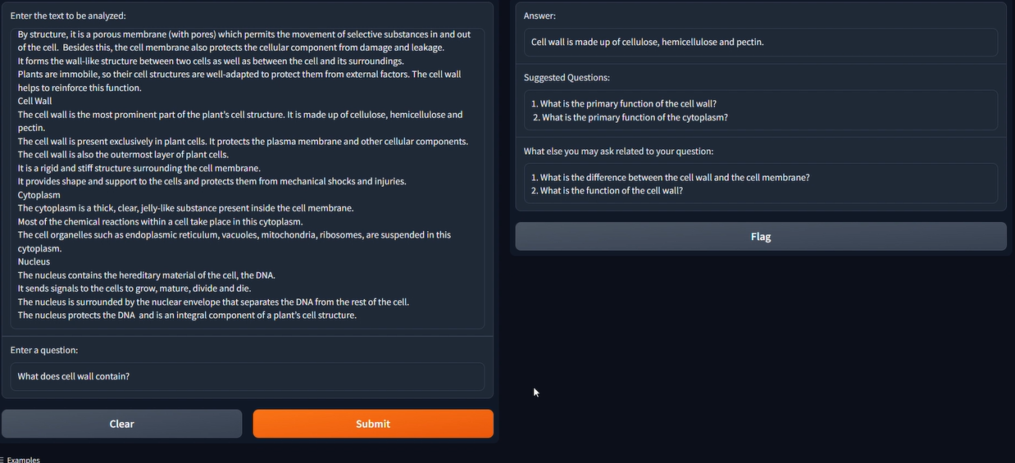](https://user-images.githubusercontent.com/131484692/233830534-52e7980b-ac86-4523-a548-ddbf139c6ab8.png)

Please find a guide me file on how you can run this code on your own system in the same repository.